Hilary DIXON meets the pupils of the Australian International Section

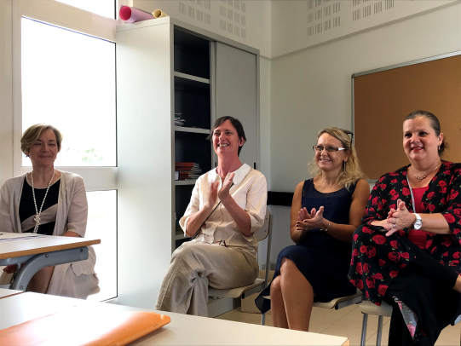
Hilary DIXON who is currently the Senior Manager of Curriculum at ACARA (Australian Curriculum Assessment and Reporting Authority) visited our school on November 30th 2017.
Upon her arrival at school, she was warmly welcome by Mrs CREUGNET, the principal of Dumbea sur Mer college, and Mrs DUBREZ, assistant to principal. Then she was greeted by the pupils of the Australian International Section who made a speech in English.
Her visit ended with the observation of a history and geography class, given by Mrs AVILES, to have a glimpse of what is taught in the Australian International Section curriculum.
